**Pseudocode:**

1. ItemToPurchase Class:

- Attributes:

- `item_name`: string, default "none"

- `item_price`: float, default 0.0

- `item_quantity`: int, default 0

- `item_description`: string, default "none"

- Methods:

- `__init__()`: Initialize the item with default values.

- `print_item_cost()`: Print the item's name, quantity, price, and total cost.

- `print_item_description()`: Print the item's name and description.

2. ShoppingCart Class:

- Attributes:

- `customer_name`: string, default "none"

- `current_date`: string, default "January 1, 2020"

- `cart_items`: list of `ItemToPurchase` objects

- Methods:

- `__init__()`: Initialize the shopping cart with default values.

- `add_item(item)`: Add an `ItemToPurchase` object to the cart.

- `remove_item(item_name)`: Remove an item by its name from the cart.

- `modify_item(item)`: Modify the price, quantity, or description of an item in the cart.

- `get_num_items_in_cart()`: Return the total quantity of items in the cart.

- `get_cost_of_cart()`: Return the total cost of the items in the cart.

- `print_total()`: Print the total number of items and the total cost.

- `print_descriptions()`: Print the description of all items in the cart.

3. print_menu(cart):

- Display menu options:

- `a`: Add item to cart

- `r`: Remove item from cart

- `c`: Change item quantity

- `i`: Output items' descriptions

- `o`: Output shopping cart total

- `q`: Quit

- Loop:

- Prompt the user to choose an option.

- Call the respective method based on the option chosen.

- Quit when the user chooses `q`.

4. main() Function:

- Prompt the user for their name and today's date.

- Create a `ShoppingCart` object using the name and date.

- Call `print_menu(cart)` to start the program and allow user interaction.

**Source code:**

# Define the ItemToPurchase class

class ItemToPurchase:

def __init__(self, name="none", price=0.0, quantity=0, description="none"):

self.item_name = name

self.item_price = price

self.item_quantity = quantity

self.item_description = description

# Method to print item cost

def print_item_cost(self):

total_cost = self.item_price * self.item_quantity

print(f'{self.item_name} {self.item_quantity} @ ${self.item_price} = ${total_cost}')

# Method to print item description

def print_item_description(self):

print(f"{self.item_name}: {self.item_description}")

# Define the ShoppingCart class

class ShoppingCart:

def __init__(self, customer_name="none", current_date="January 1, 2020"):

self.customer_name = customer_name

self.current_date = current_date

self.cart_items = []

# Adds an item to the cart

def add_item(self, item_to_purchase):

self.cart_items.append(item_to_purchase)

# Removes an item from the cart by name

def remove_item(self, item_name):

item_found = False

for item in self.cart_items:

if item.item_name == item_name:

self.cart_items.remove(item)

item_found = True

break

if not item_found:

print("Item not found in cart. Nothing removed.")

# Modifies an item’s description, price, or quantity

def modify_item(self, modified_item):

item_found = False

for item in self.cart_items:

if item.item_name == modified_item.item_name:

if modified_item.item_description != "none":

item.item_description = modified_item.item_description

if modified_item.item_price != 0:

item.item_price = modified_item.item_price

if modified_item.item_quantity != 0:

item.item_quantity = modified_item.item_quantity

item_found = True

break

if not item_found:

print("Item not found in cart. Nothing modified.")

# Returns total number of items in the cart

def get_num_items_in_cart(self):

return sum(item.item_quantity for item in self.cart_items)

# Calculates and returns the total cost of the cart

def get_cost_of_cart(self):

total_cost = 0

for item in self.cart_items:

total_cost += item.item_price * item.item_quantity

return total_cost

# Prints the total cost of the shopping cart

def print_total(self):

if len(self.cart_items) == 0:

print("SHOPPING CART IS EMPTY")

else:

print(f"{self.customer_name}'s Shopping Cart - {self.current_date}")

print(f"Number of Items: {self.get_num_items_in_cart()}")

for item in self.cart_items:

item.print_item_cost()

print(f"Total: ${self.get_cost_of_cart()}")

# Prints descriptions of each item in the cart

def print_descriptions(self):

if len(self.cart_items) == 0:

print("SHOPPING CART IS EMPTY")

else:

print(f"{self.customer_name}'s Shopping Cart - {self.current_date}")

print("Item Descriptions")

for item in self.cart_items:

item.print_item_description()

# Function to display the menu and process user input

def print_menu(cart):

while True:

print("\nMENU")

print("a - Add item to cart")

print("r - Remove item from cart")

print("c - Change item quantity")

print("i - Output items' descriptions")

print("o - Output shopping cart")

print("q - Quit")

choice = input("Choose an option: ").lower()

if choice == 'a':

name = input("Enter item name: ")

description = input("Enter item description: ")

price = float(input("Enter item price:$ "))

quantity = int(input("Enter item quantity: "))

item = ItemToPurchase(name, price, quantity, description)

cart.add_item(item)

elif choice == 'r':

name = input("Enter the name of the item to remove: ")

cart.remove_item(name)

elif choice == 'c':

name = input("Enter the name of the item to modify: ")

description = input("Enter the new description (or 'none' to leave unchanged): ")

price = float(input("Enter the new price (or 0 to leave unchanged): "))

quantity = int(input("Enter the new quantity (or 0 to leave unchanged): "))

modified_item = ItemToPurchase(name, price, quantity, description)

cart.modify_item(modified_item)

elif choice == 'i':

cart.print_descriptions()

elif choice == 'o':

cart.print_total()

elif choice == 'q':

break

else:

print("Invalid option, try again.")

# Main function to start the program

def main():

customer_name = input("Enter customer's name: ")

current_date = input("Enter today's date: ")

cart = ShoppingCart(customer_name, current_date)

print_menu(cart)

if __name__ == "__main__":

main()

**Screenshots of application running the program:**

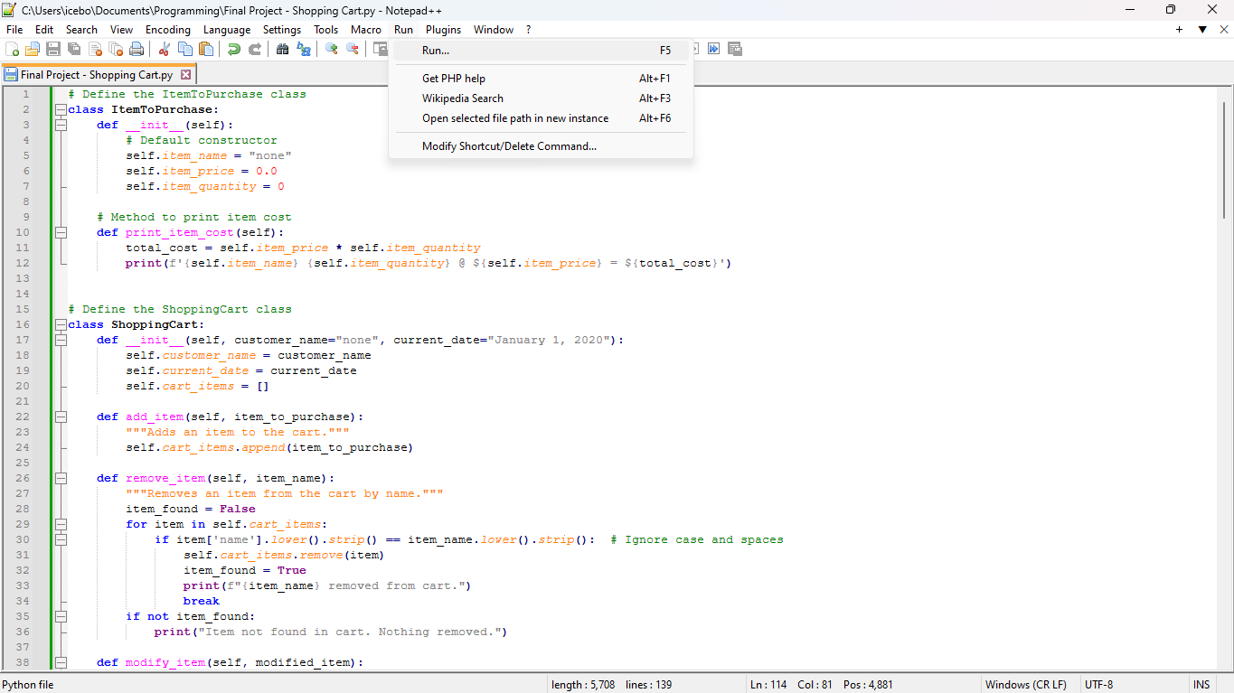

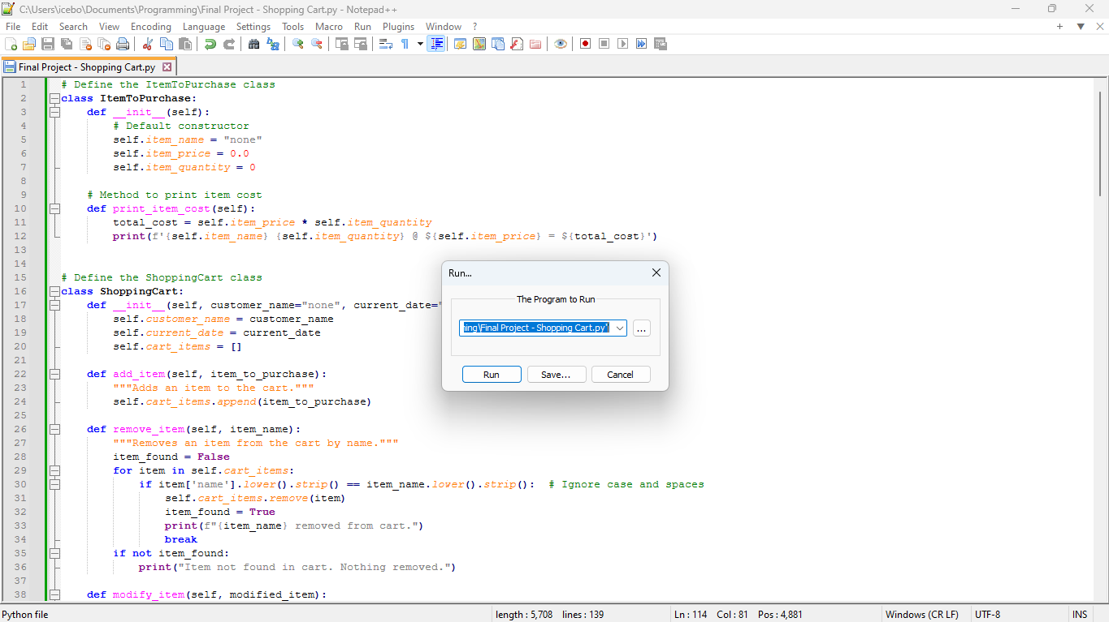

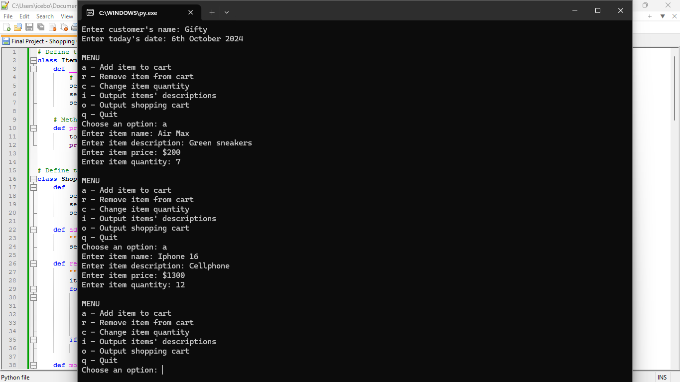

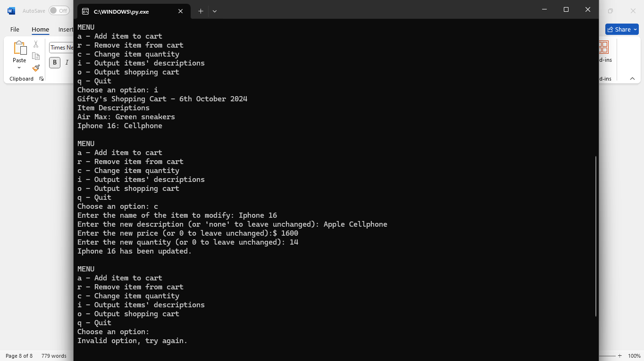

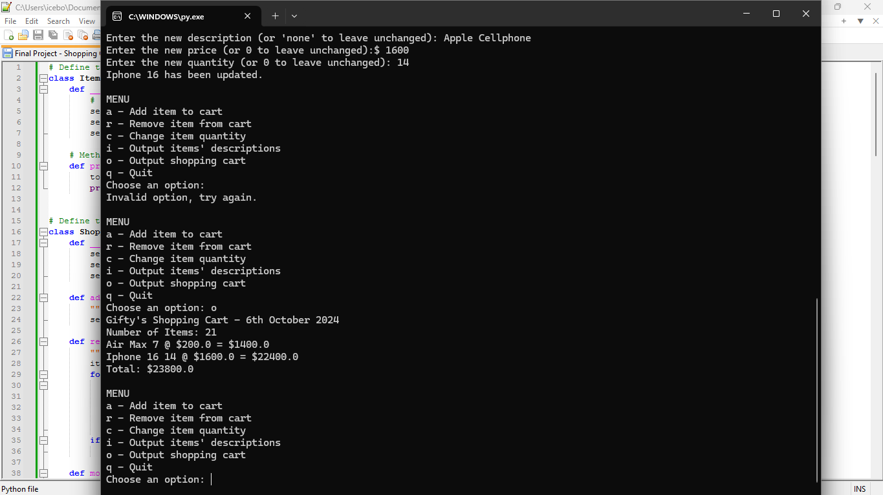

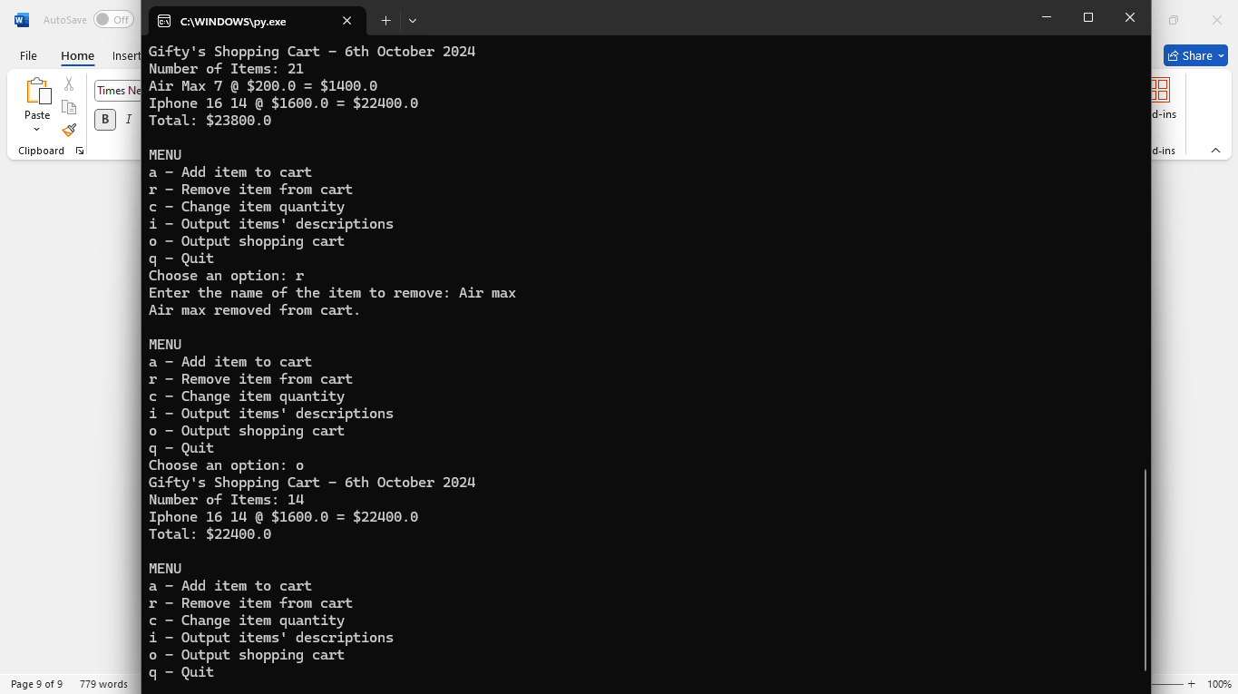

**GIT Repository link:**

<https://github.com/giftataylor/Week-8-final-project/upload>